# Target setting and reporting guidance for parents and carers 2023-24

Dear Parent/Carer,

All GCSE examination grades have now changed to a 9-1 based system, as shown in the diagram below:

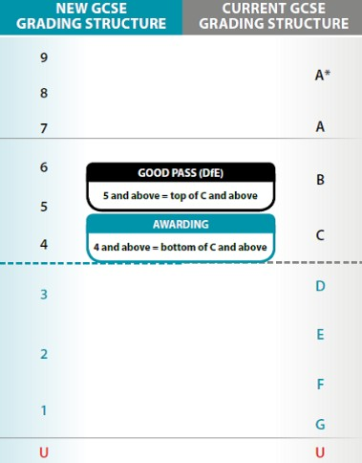

# Target setting and Flightpaths

Most children in the UK take national tests (SATs) in English and Mathematics at the end of Year 6. The Government then estimates what GCSE grades students should achieve in Year 11.

The City of Derby Academy uses these Government estimates to set GCSE targets for all students from Year 7 onwards. If a student did not sit the Year 6 SATs we set targets based on cognitive ability tests (CATs).

All students are on a “Flightpath” (FP) which links to the GCSE grade they are expected to achieve in Year 11. For example, a student on FP6 is expected to achieve GCSE Grade 6 at the end of Y11.

## Please note that:

* Flightpaths are initially based on how well a student performed in Year 6.
* Students may have different Flightpaths in different subjects.
* The performance and progress of all students is monitored throughout the year.
* Flightpaths may change over time depending on student performance and progress.
* Parents and carers will be updated on their child’s performance and progress throughout the year.

# Reporting

Reports are issued in the last week of term. All students will receive a detailed report three times per year (December, April, July) except Year 11s who will receive two.

If you have any further questions about target setting or reporting, please contact us at

[**admin@cityofderbyacademy.org**](mailto:admin@cityofderbyacademy.org)

# Your child’s report

We will be updating our reports this year, but a current ‘snapshot’ of what your child’s report will look like is shown here:

